|  |  |
| --- | --- |
| **Title** | 1st Homework in the Basic Python Class by 201923250 |

|  |  |  |  |
| --- | --- | --- | --- |
| **Author** | 201923250 | **Date** | 9.3.2020 |

**Summarization**

Python is a widely-used programming language. It is even used by NASA, Google and Youtube. We run python programs using an IDLE which stands for Integrated Development Environment.

**Installing python**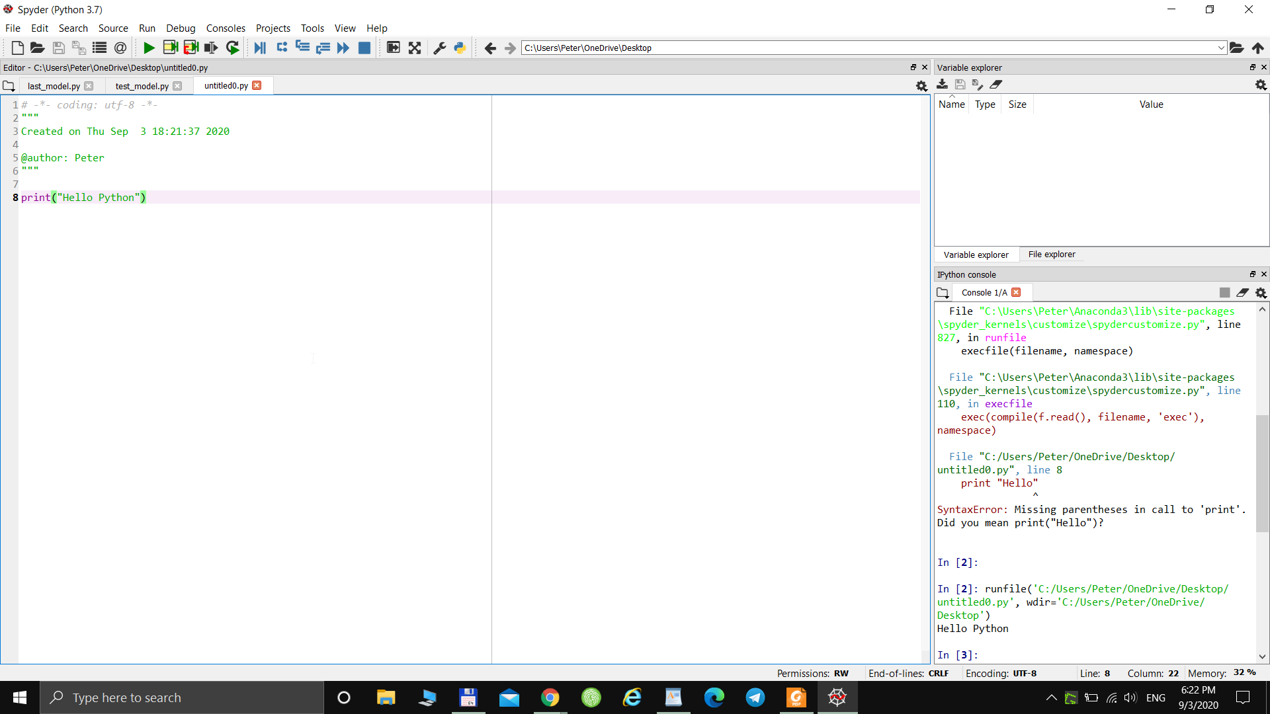

Python is already installed on my computer, so I’m just taking a screenshot of that. I installed Anaconda, Spyder3 and Jupyter Notebook environments other than the official IDLE to work with .py files.

Thank you